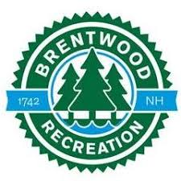
PROGRAM & EVENT ALERT SIGN UP

Do you feel like you are always missing deadlines for Brentwood Recreation events or programs? Brentwood Rec is starting an alert system through email, to let you know which program or event has open registrations. All you have to do is visit the recreation office or website and fill out the Program & Event Alert form for which activities you would like to be notified for. For further questions or details please email or call the recreation office

Phone: 603-642-6400 ext.120 Email: recreation@brentwoodnh.gov

Please check off which items you would like to have Brentwood Recreation email you when programs or events open.
Adult Programs
- Co-ed Softball
- Men’s Basketball
- Ceramics
- Senior Luncheons
- Senior Yoga
- Zumba
- Sip and Sign
- Yoga
- Adult Pickleball
Youth Programs
- Ski Club (anyone can go)
- Challenger Soccer Camp
- Summer Camp
- Vacation Camp
- Hiking Trips
- Youth Pickleball
- Calls from the North Pole
Youth Sports
- Baseball
- Softball
- Basketball
- Flag Football
- Soccer
- Field Hockey
Events
- Casino Trips
- Boston Red Sox
- UNH Hockey
- Baby Sitting Training
- Boo Bash
- Movie Night
- Bunny Breakfast
- Family Skate Night
- 4th of July Parade
- CPR course

NAME: ___________________________ EMAIL: ______________________________

