BRC Trails
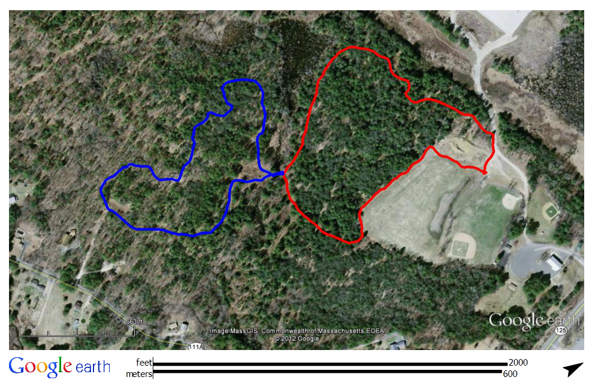
Town of Brentwood, NH
Town right-of-way
off 111A
Goes to Fremont’s Glen Oakes Town Forest Trails
S
wa
mp
Main Archery Area
Culvert
Kiosk
You Are Here
South Loop
*Trails are marked with blue markers. The colors seen here are for separation purposes only.
Powerlines
Powerlines
North Loop

